Packet switching
IGCSE Computer Science 0478 | 2.1 Data transmission | Student booklet
Name: _______________________________ | Date: _____________

This booklet has everything you need for the lesson in one place. Work through it in order:
- Learn sections show the key slides. Read them carefully - they explain the ideas and show worked examples.
- Task sections are where you practise. Each task uses what the slides just before it taught you.
- Tasks get harder as you go and are written like Cambridge IGCSE Paper 1 questions. Task 5 is an extension.
Do Task 1 before you turn the page - you will come back to it at the end.
Task 1 Starter - True or False? [5 marks]
Answer now from what you already know. At the end of the lesson, come back and correct any you got wrong.
Statement | True | False | Correction (end of lesson)
A large file is sent across the internet in one piece.
Each packet contains the address of the computer it is going to.
All the packets in a message must travel along the same route.
Packets can arrive at the destination in a different order from the order they were sent in.
The sending computer decides the route that every packet takes.

Learn Packets and their structure
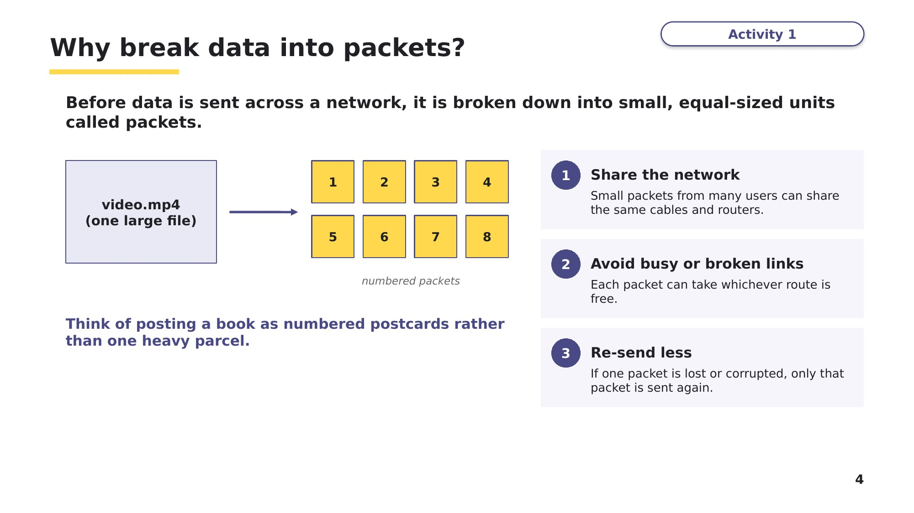
Slide 4 - Why break data into packets?
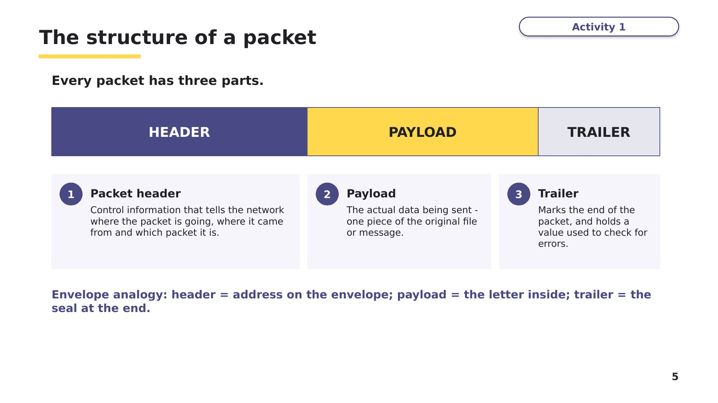
Slide 5 - The structure of a packet
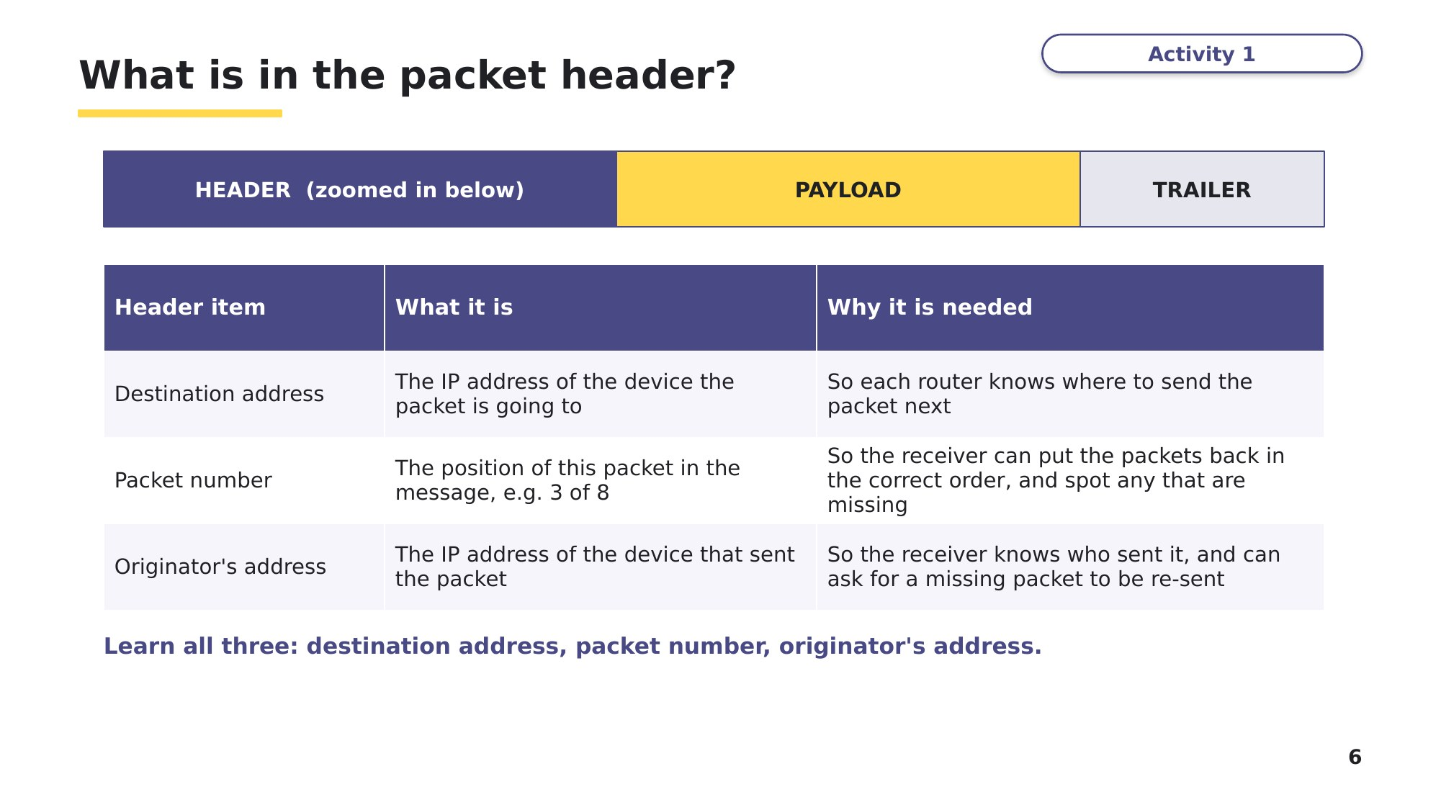
Slide 6 - What is in the packet header?
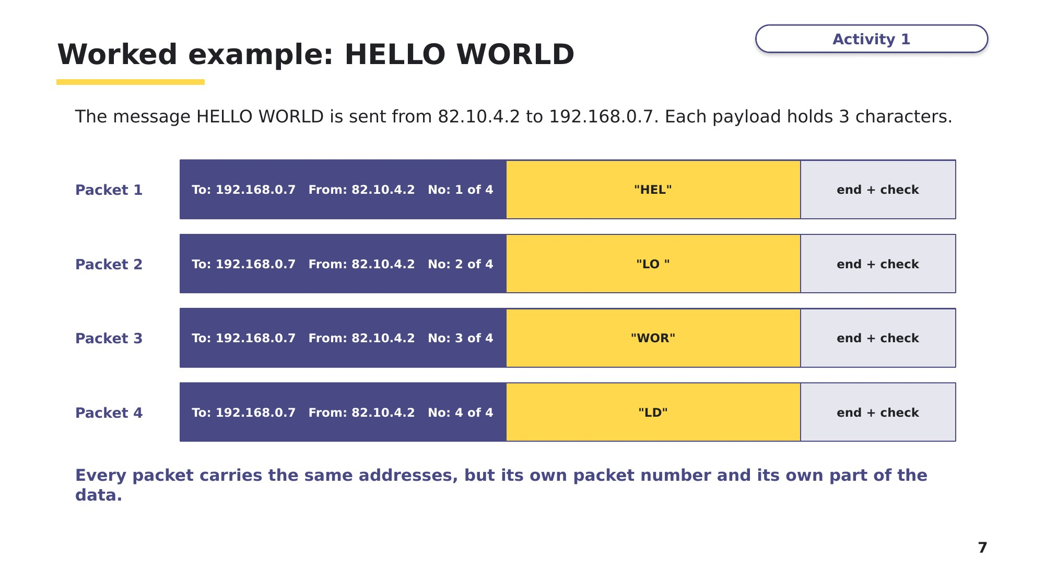
Slide 7 - Worked example: HELLO WORLD
Task 2 The structure of a packet [6 marks]
(a) Complete the diagram by writing the name of each part of a packet. [3]
Part 1 | Part 2 | Part 3

(b) State three items of data that are stored in the packet header. [3]
1 ___________________________________________________
2 ___________________________________________________
3 ___________________________________________________

Learn Packet switching
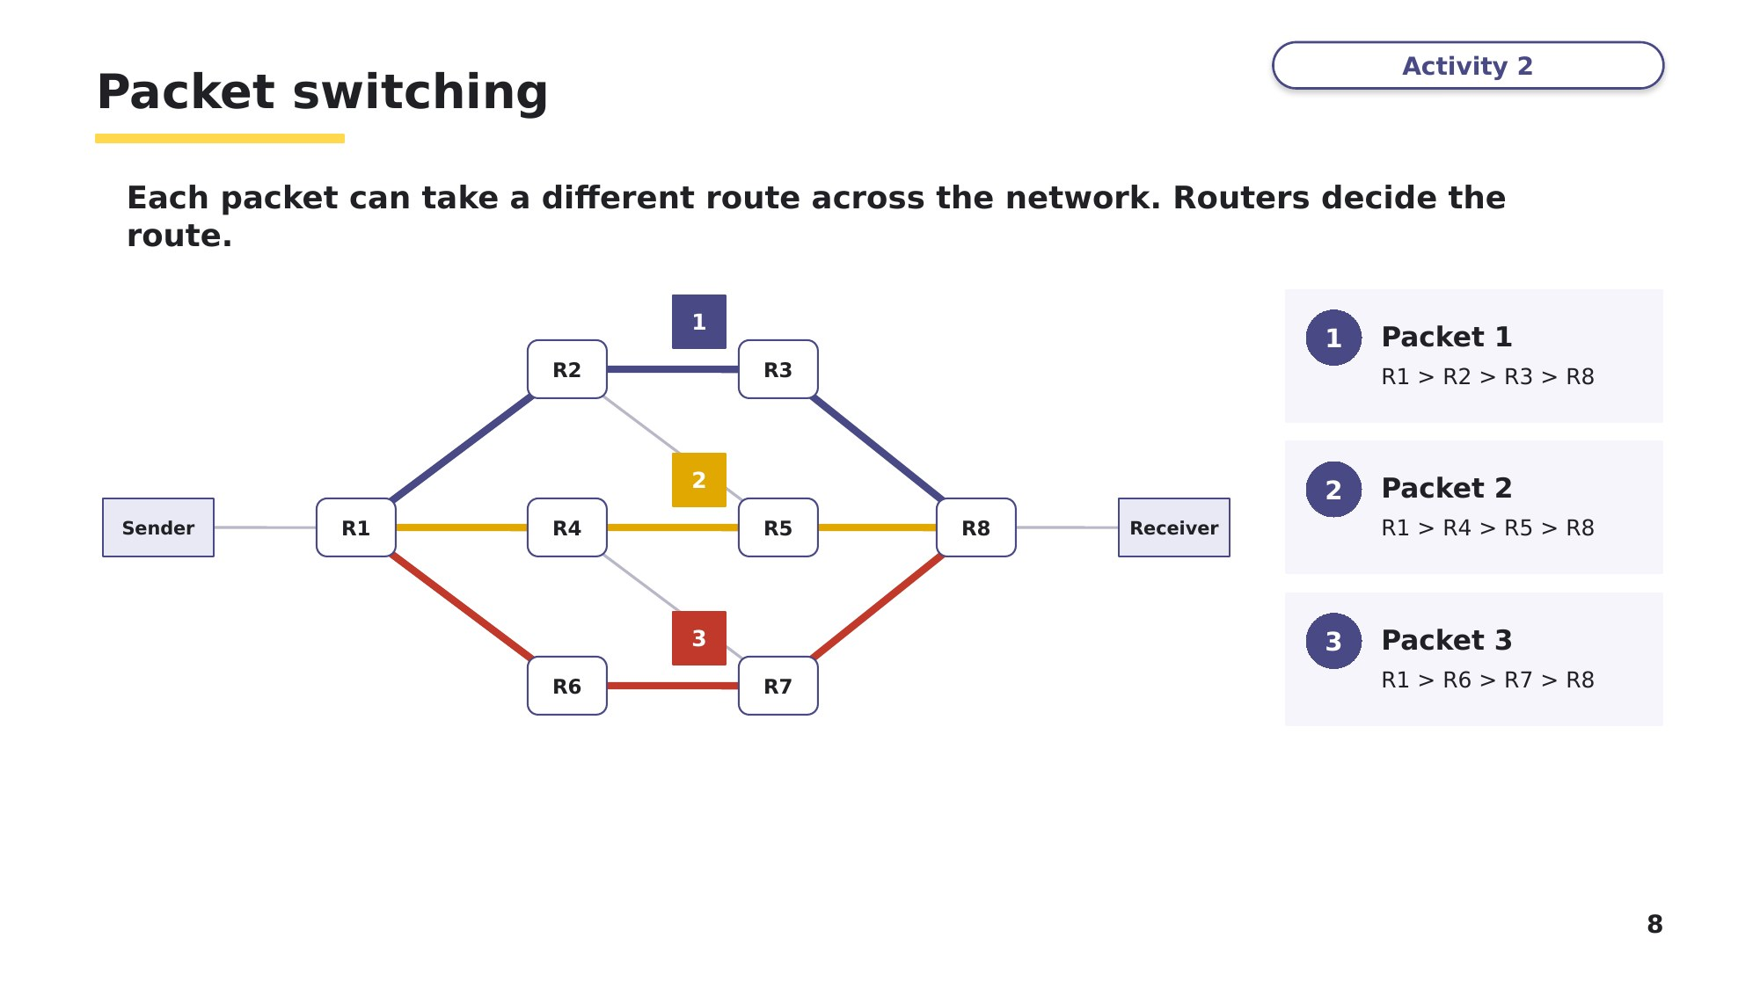
Slide 8 - Packet switching
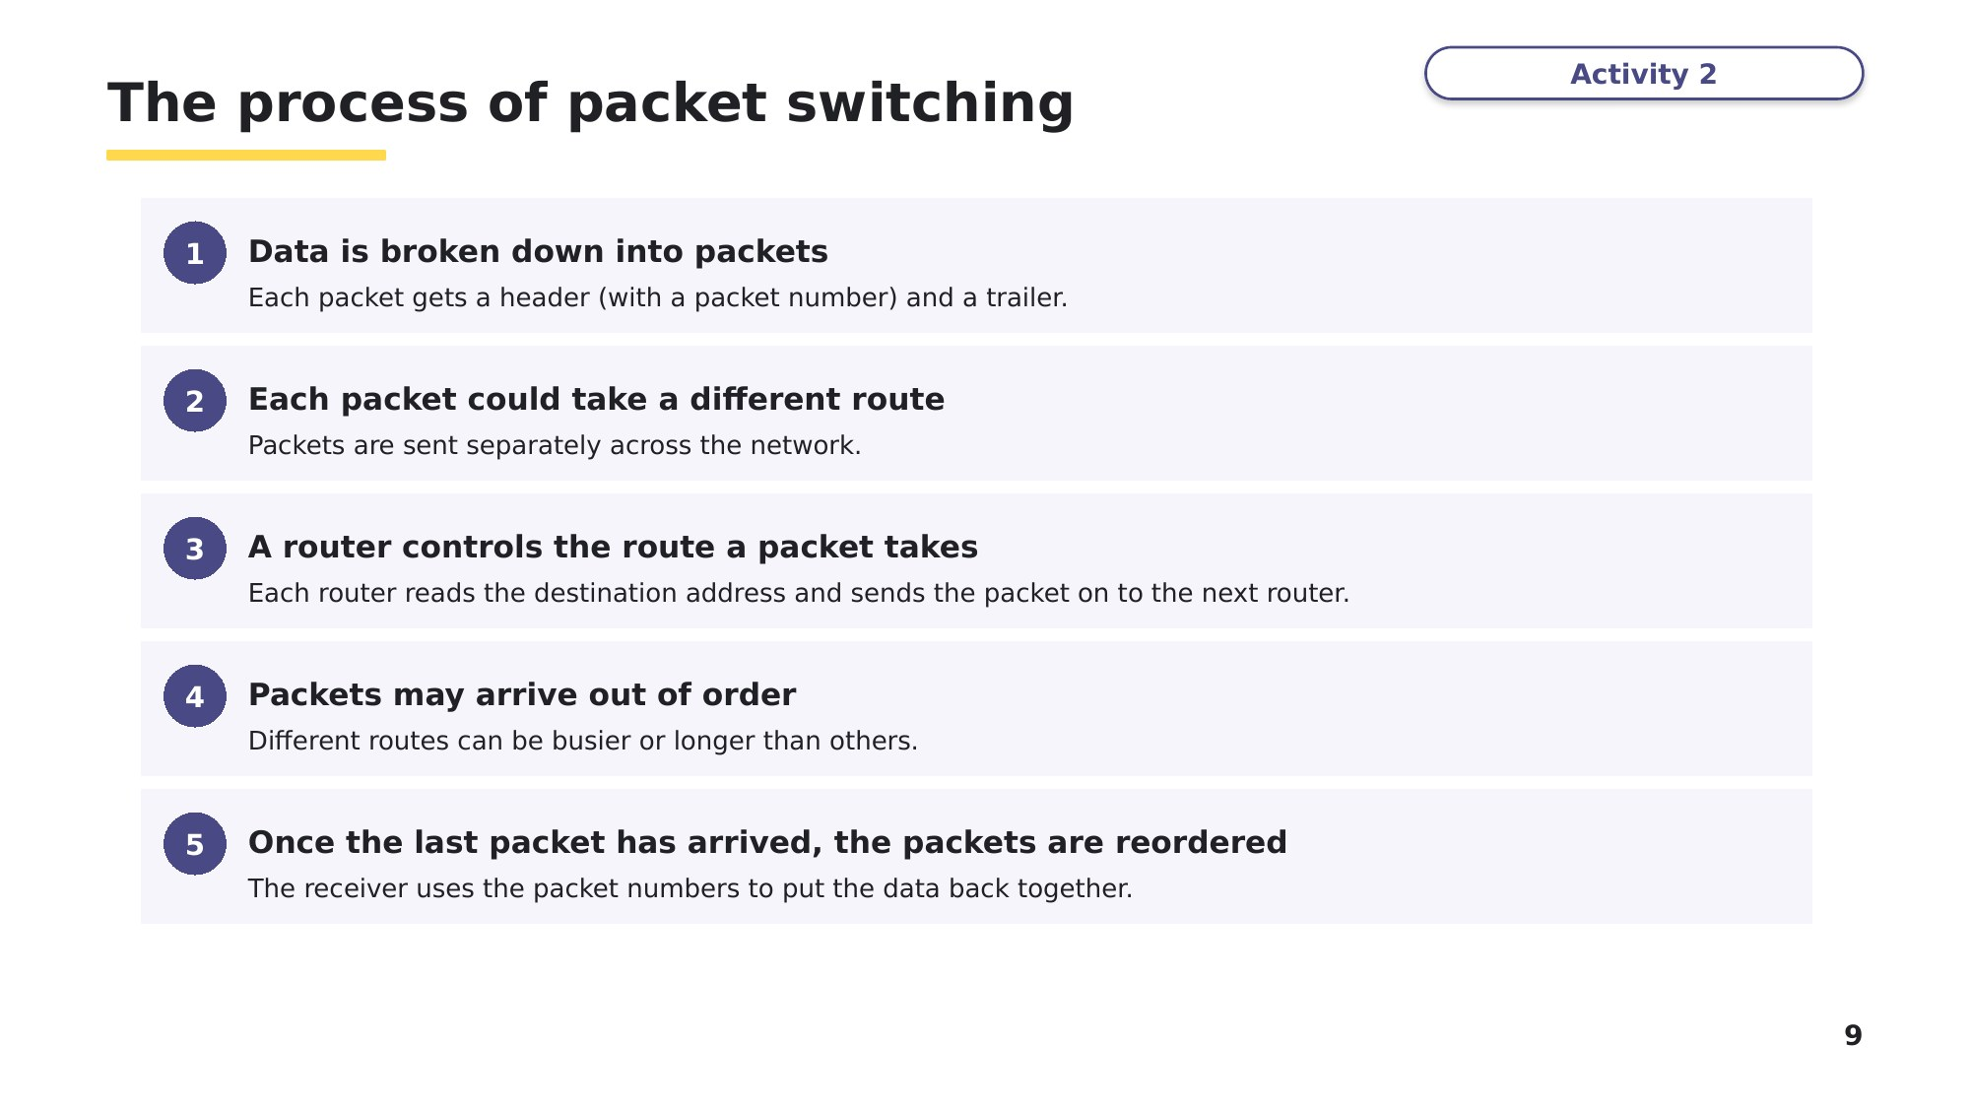
Slide 9 - The process of packet switching
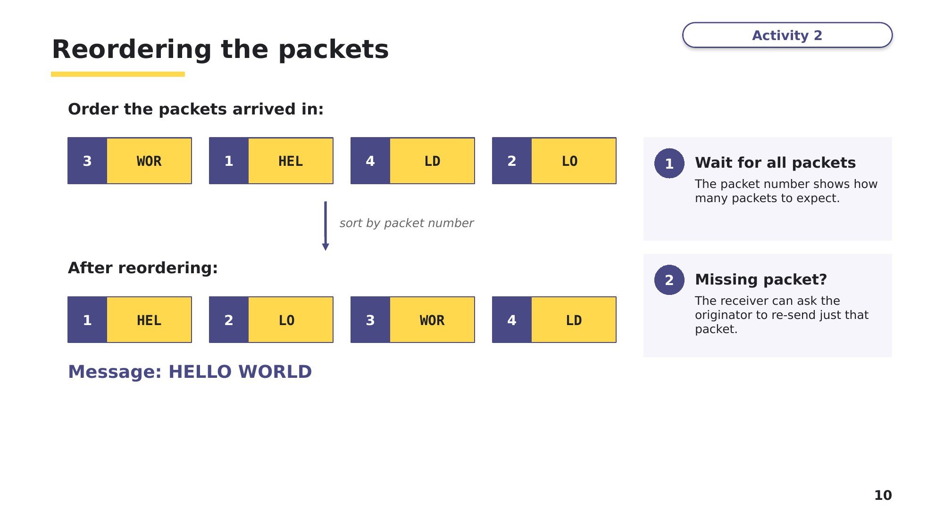
Slide 10 - Reordering the packets
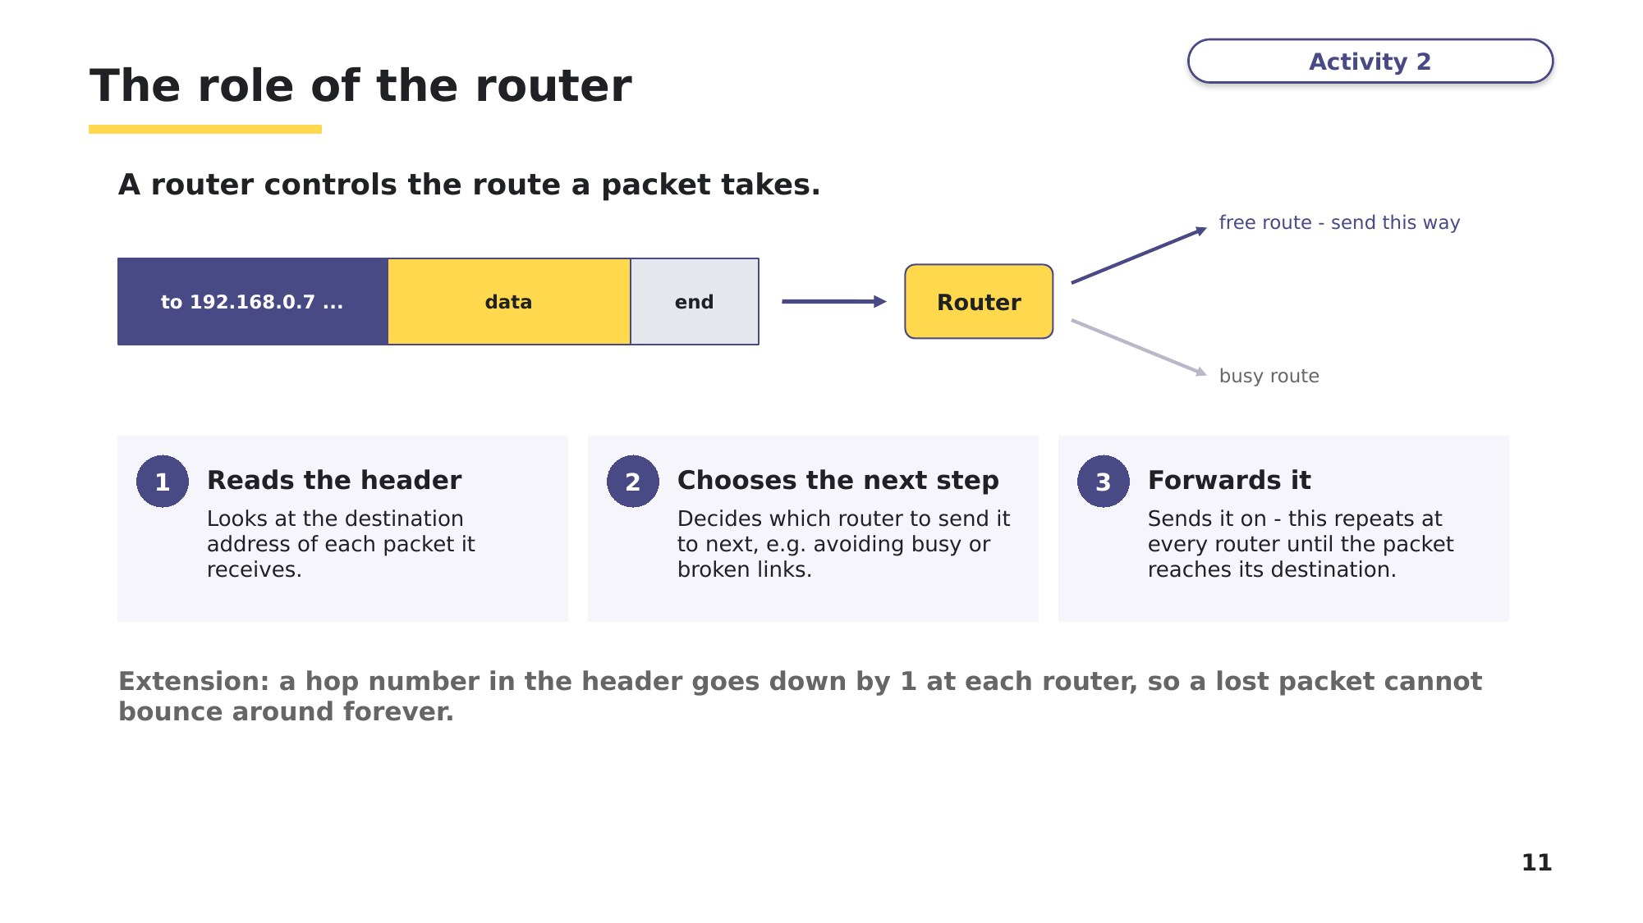
Slide 11 - The role of the router

Task 3 Split it up, then put it back together [6 marks]
(a) The message PACKETSWITCH is sent from 82.10.4.2 to 192.168.0.7. Each payload holds 4 characters. Complete the table for every packet. [3]
Destination address | Originator's address | Packet number | Payload

(b) A different message is sent as five packets. They arrive in this order: packet 4 "ER", packet 1 "CO", packet 3 "UT", packet 5 "S!", packet 2 "MP". Write the message after the packets have been reordered, and state when the reordering happens. [2]

(c) Packet 1 travelled through 6 routers and packet 3 travelled through 3 routers. Give one reason why packet 1 could still arrive before packet 3. [1]

Learn Why packet switching?
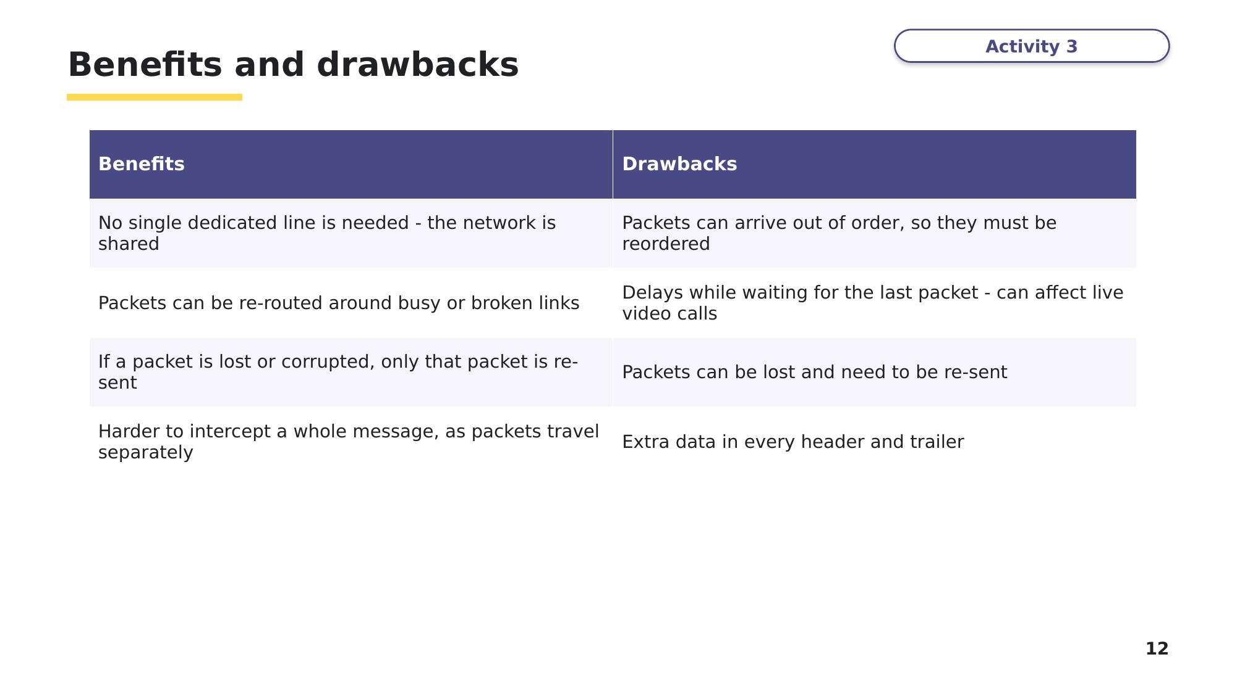
Slide 12 - Benefits and drawbacks
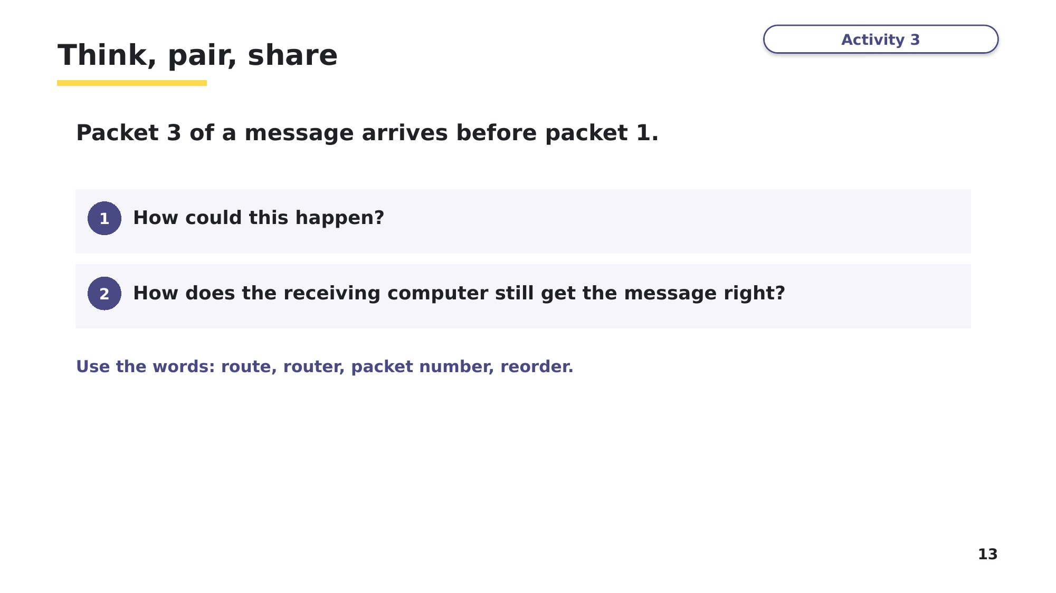
Slide 13 - Think, pair, share
Task 4 Exam-style questions [11 marks]
These questions are written in the style of Cambridge IGCSE 0478 Paper 1, using the wording of the syllabus.
(a) Explain why data is broken down into packets before it is transmitted across a network. [2]

(b) Identify the part of a packet that contains the actual data being sent. [1]

(c) Describe the process of packet switching. [5]

(d) State the role of a router in packet switching. [1]

(e) Explain why the packet number is needed in the packet header. [2]

Learn Check your Task 4(c) answer
Only look at this slide once you have finished Task 4. Mark (c) against these points.
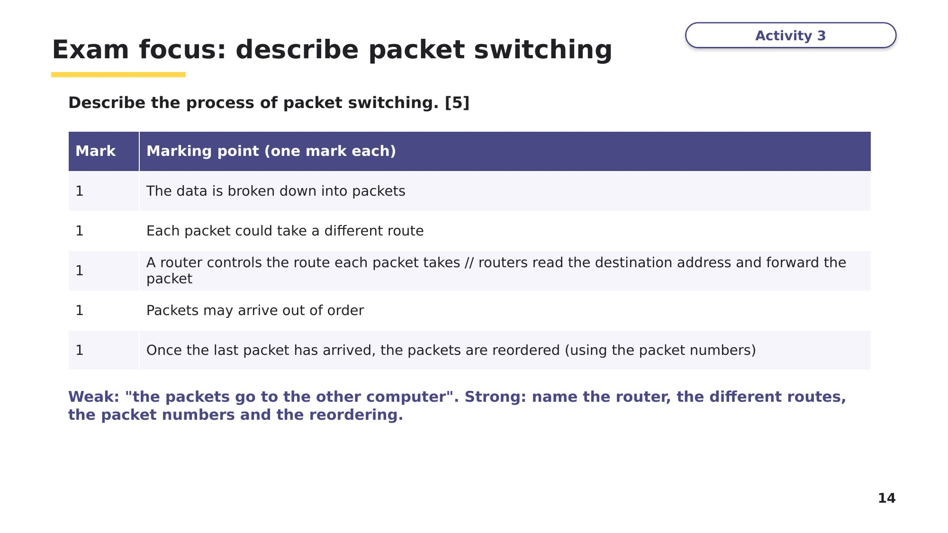
Slide 14 - Exam focus: describe packet switching
Task 5 Extension [4 marks]
A school uses the internet for live video calls with a partner school in another country.
(a) Explain one benefit of packet switching for these video calls. [2]

(b) Explain one drawback of packet switching for these video calls. [2]

Learn Review
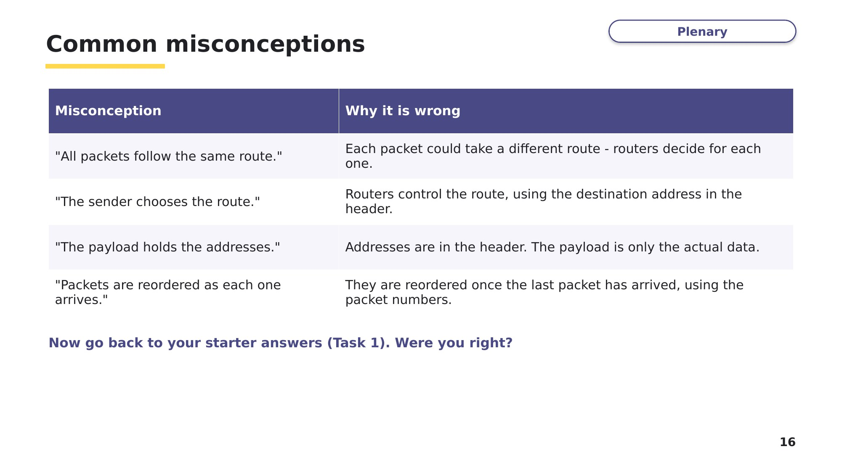
Slide 16 - Common misconceptions
Now go back to Task 1 and write a correction next to any statement you got wrong.
Exit question
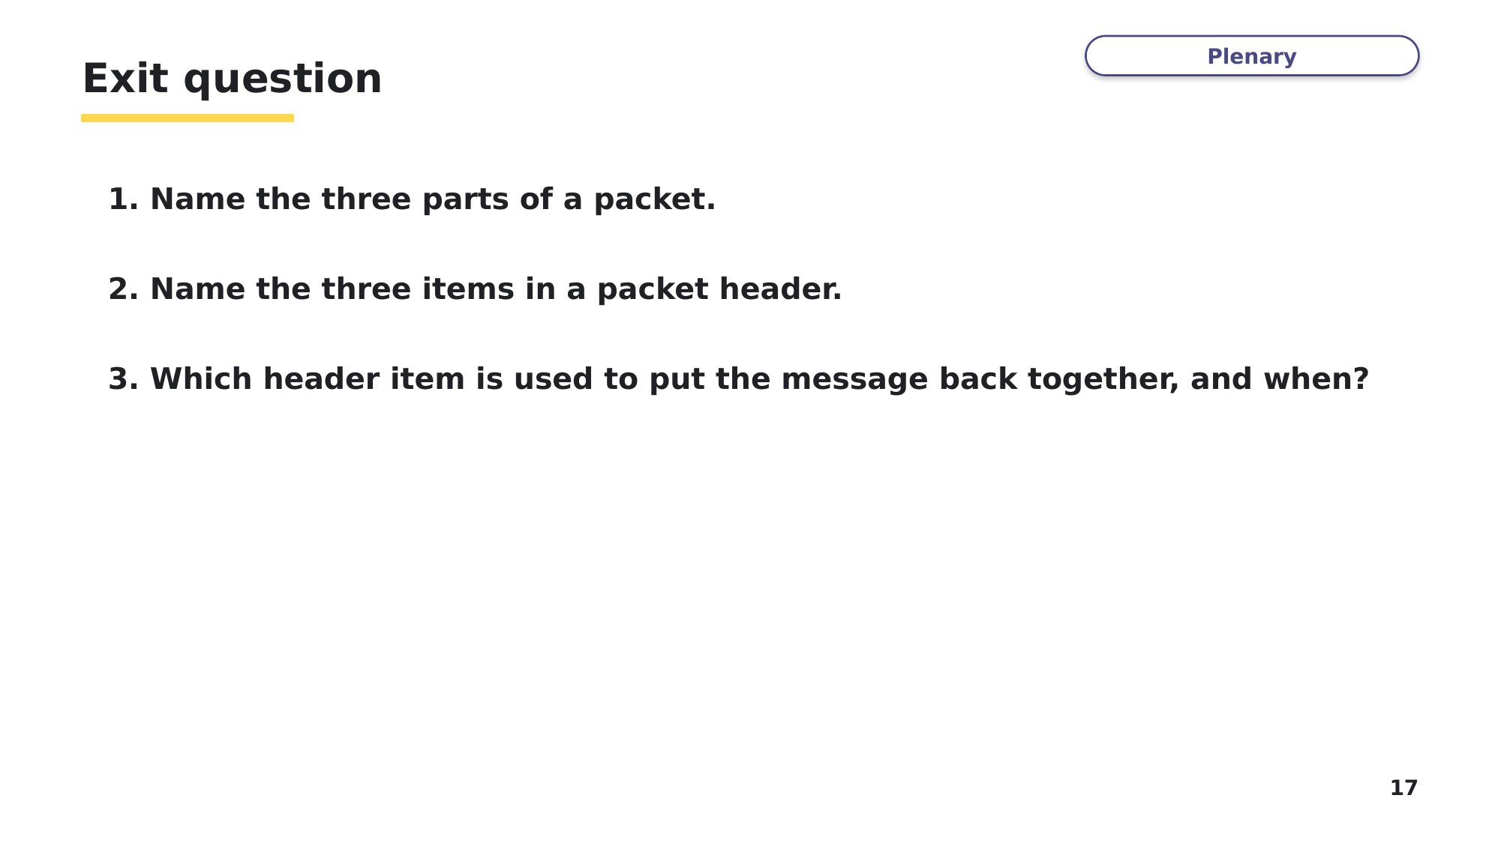
Slide 17 - Exit question

